**ASAD ULLAH**

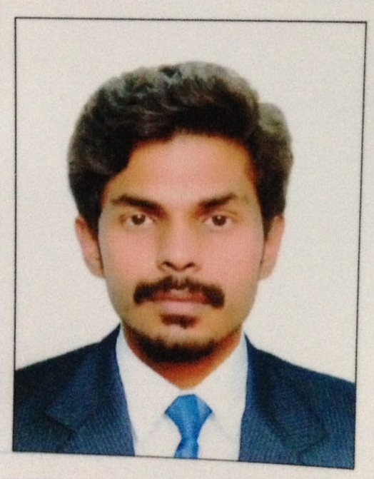

***Personal Info & Interest***

*Father name: ARSHAD HUSSAIN*

*Date of Birth: 31 JUL 1995*

*Nationality: Pakistani*

*Religion: Islam*

*CNIC No# 33202-4289069-9*

*Material Status: Single*

*Languages: English, Urdu*

*Games: Football, Cricket*

***Contact Info***

*Address: House no 318, street no 13, sector 3, AECHS, Rawalpindi, Pakistan*

*MOB: 0334-7693971*

*E-mail: asad.gujjar945@gmail.com*

***Objective:***

Seeking a job eventually leading to professional carrier in a dynamic organization like yours, having attractive working environment prospects of growth and learning where I can utilize my skills with strong commitment and dedication to contribute to your organization’s success.

***Education***

* Matric from Federal Board, 2011
* FSC Pre-Medical from Federal Board, 2013
* BS Computer Science from UNIVERSITY OF LAHORE

***Projects and Subjects***

1. **MAJOR COURSES**

* DATA STUCTURE
* WEB PROGRAMMING
* OBJECT ORIENTED PROGRAMMING
* THEORY OF AUTOMATA
* ADVANCE SOFTWARE ENGINEERING
* COMPUTER COMMMUNICATION AND NETWORK
* DISTRIBUTED DATABASE
* GRAPHIC DESIGNING
* ARTIFICAL INTELLIGENCE
* DATA NETWORK SECURITY
* INFORMATION SECURTIY
* DATA IMAGE PROCESSING
* DATA MINING

1. **UNIVERSITY PROJECTS**

* **Final year project:** FIRST PERSON SHOOTING GAME USING UNITY3D
* **Mini projects:**
* ONLINE BANKING SYSTEM MODELING
* EMBEDED CONTROL SYSTEM MODELING
* ACADEMIC SYSTEM MODELING, SCHOOL
* INFORMATION SYSTEM PROJECT MANAGEMENT
* CRICKET STADIUM USING OPENGL

***Expertise and Skills***

* Operating Systems: Microsoft Windows 98, 2000, XP, Vista, windows 7, 8, 8.1. 10
* MS Office 2007, 2010
* Software: C/C++, Unity3d, Blender, adobe Photoshop, HTML, CSS, JAVA.
* NETWORKING AND SHARING
* Good knowledge of Graphics, data management.

***Personal Attributes***

* Self-Confident, Honest, Sincere and Hard Working.
* Always prepared to take on responsibility even in difficult circumstances.
* Calm and exceptionally reliable at all times.
* Co-operative and trusted relations, Works well in a team.
* Able to decide routine matters.
* Always looking optimistically to every aspect of life.